**CS 2265 - Advanced Programming I (using Java)**

**Program #2 Solution**

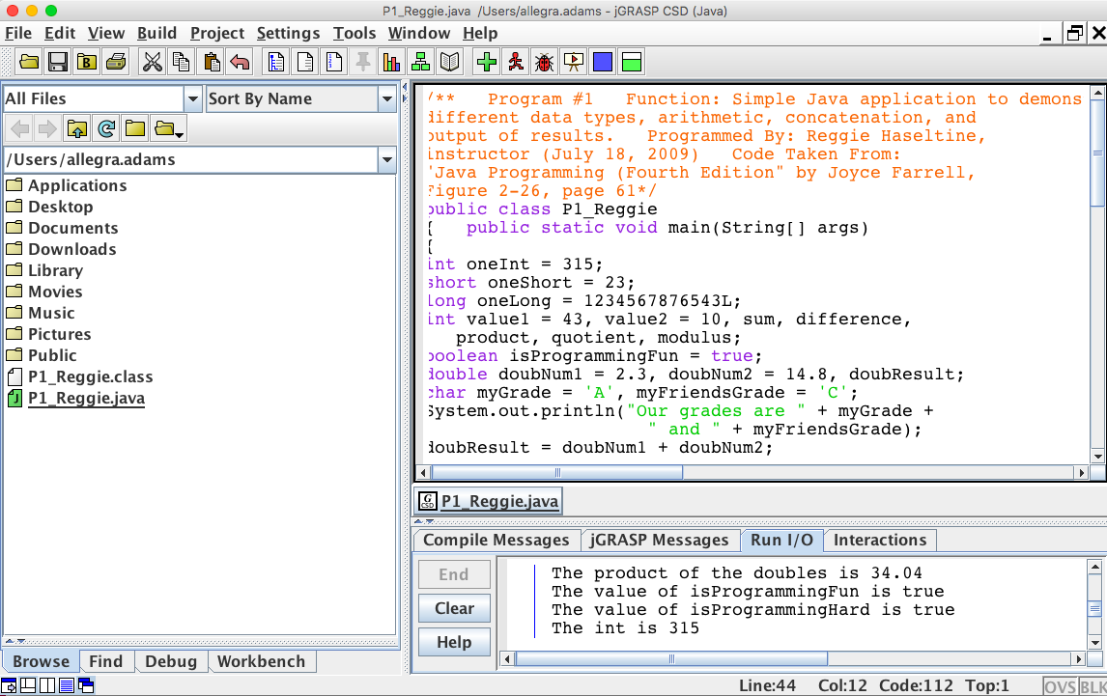

/**

   Program #1

   Function: Simple Java application to solicit and input three integers from the user and then displays the sum average, product, smallest and largest of the three numbers.

**Programmed by: Allegra Adams (October 28, 2018)**

import java.util.Scanner;

public class ArithmeticSmallestLargest {

public static void main(String[] args) {

Scanner input = new Scanner(System.in);

int num1;

int num2;

int num3;

int sum;

int average;

int product;

int largest;

int smallest;

System.out.print("First Number: ");

num1 = input.nextInt();

System.out.print("Second Number: ");

num2 = input.nextInt();

System.out.print("Third Number: ");

num3 = input.nextInt();

sum = num1 + num2 + num3;

average = sum / 3;

product = num1 * num2 * num3;

largest = num1;

smallest = num1;

if(num2 > largest)

largest = num2;

if(num3 > largest)

largest = num3;

if(num2 < smallest)

smallest = num2;

if (num3 < smallest)

smallest = num3;

System.out.println("The sum: " + sum);

System.out.println("The average: " + average);

System.out.println("The product: " + product);

System.out.println("Largest of three numbers: " + largest + " Smallest of three numbers: "+ smallest + ".");

}

}